As we already know about logistic regression. We use this to interpret neural network.

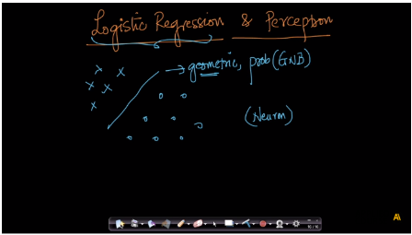

In LR we use wTx + b in sigmoid function to predict value of y.

And we train LR by finding out value of w vector and b by using Stochastic gradient descent.

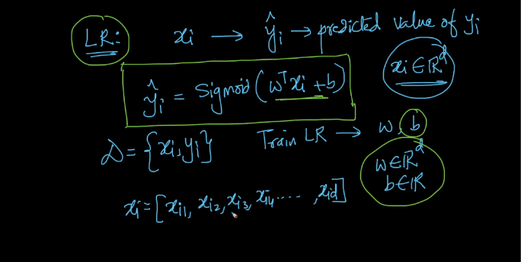

In neuron we use same summation_wtx in neuron activation function

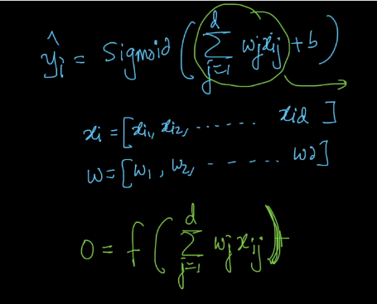

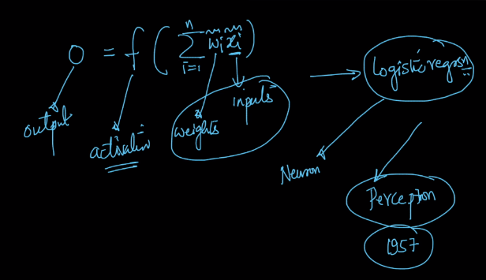

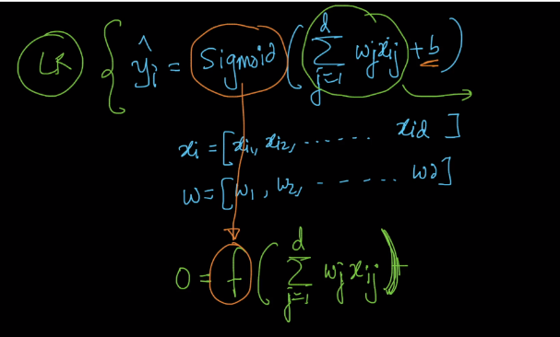

So in this way we can interpret Neural network by logistic regression. In input edges we assign weights and provide xi of d-dim. And in neuron we use sigmoid function and in this way we got output y_hat

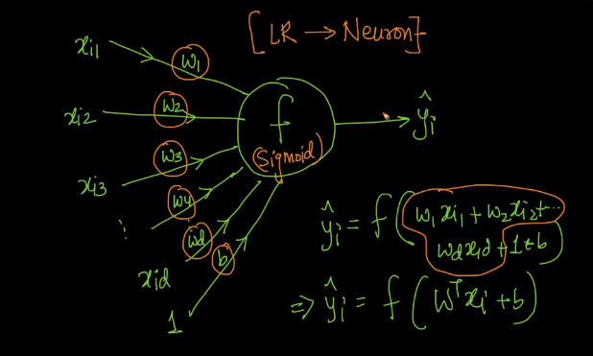

As in Logistic regression our task is to find w and b in training time and we do this using SGD.

Similarly while training neural network we have to find a weights on edges/vertices.

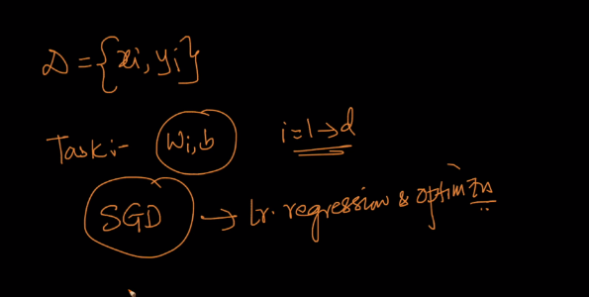

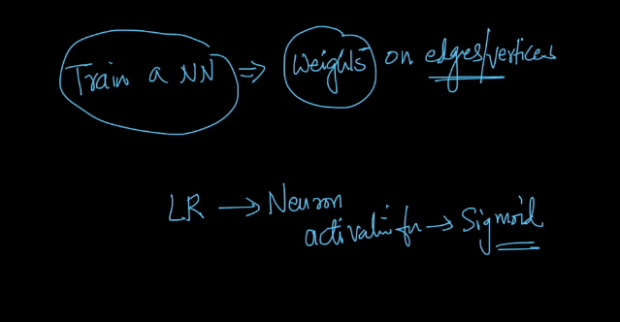

**Perceptron :**

Perceptron is very basic neural network model. In this it uses activation function as shown below which returns 1 if wTx + b>0 otherwise it returns 0.

Or it returns 1 if neural fire or activates otherwise neural doesn’t fire.

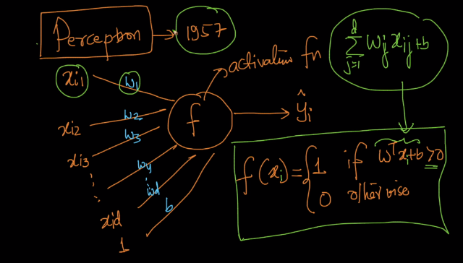

Perceptron is linear classifier it also uses line to separate positive or negative points.

It is almost similar to LR only difference is LR uses squashing in sigmoid function and perceptron doesn’t use it and classify points which is of any distance.

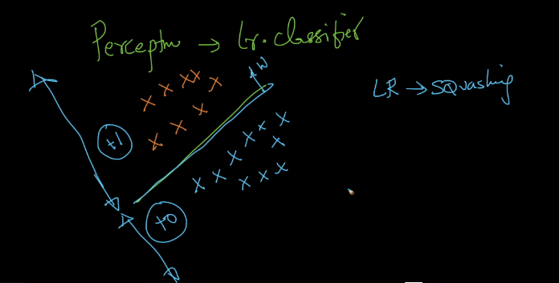

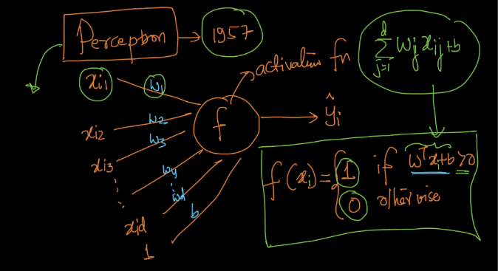

Perceptron is a simple single neuron models.

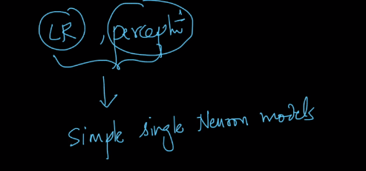

Comments :

